DATA ANALYTICS ASSIGNMENT 3

PULUSU BABY VINEELA

20NN1A05G7

IV B.TECH (CSE)

VIGNAN’S NIRULA INSTITUTE OF TECHNOLOGY AND SCIENCE FOR WOMEN (VNITSW)

**DATASET USED:**

Sample - Superstore (1).xls

* **Define at least two sets based on specific criteria from your dataset (e.g., highvalue customers, top-performing products).**
* **Experiment with combining sets using UNION, INTERSECT, and MINUS operations.**
* **Create 2 Calculated Fields using any Aggregate Functions**
* **Create any 3 Visualization using Quick Table Calculations**

HIGH VALUE CUSTOMERS BY SALES

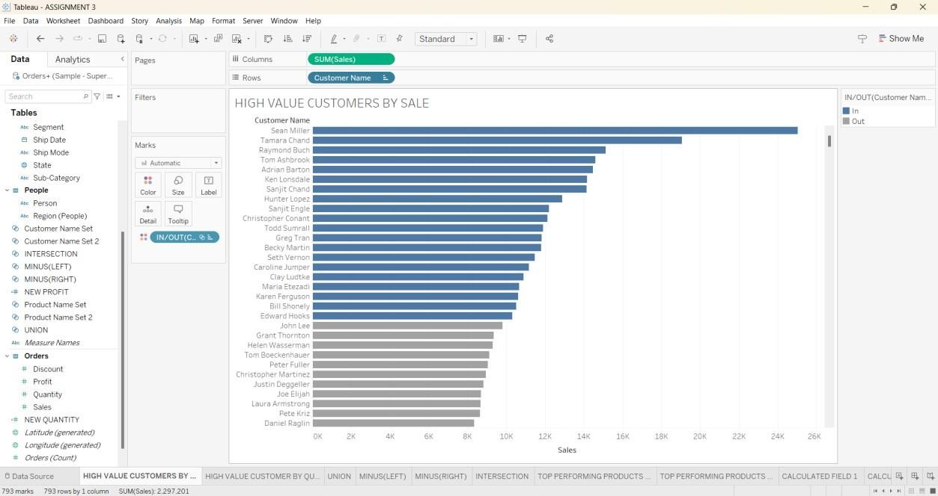

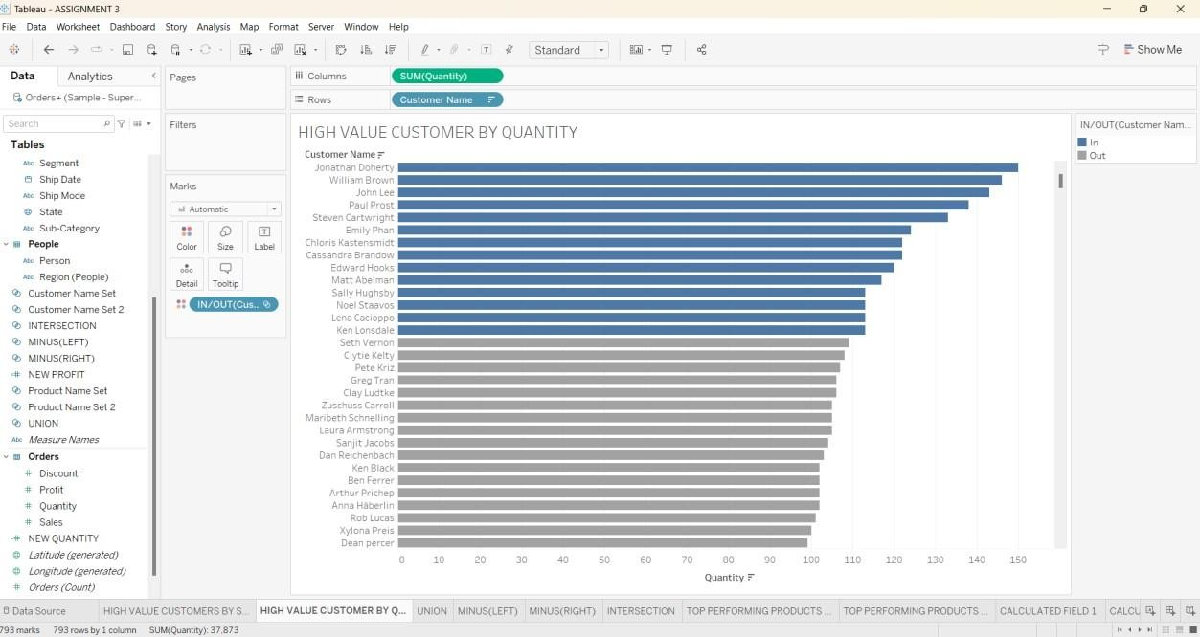

TOP PERFORMING PRODUCTS BY SALES

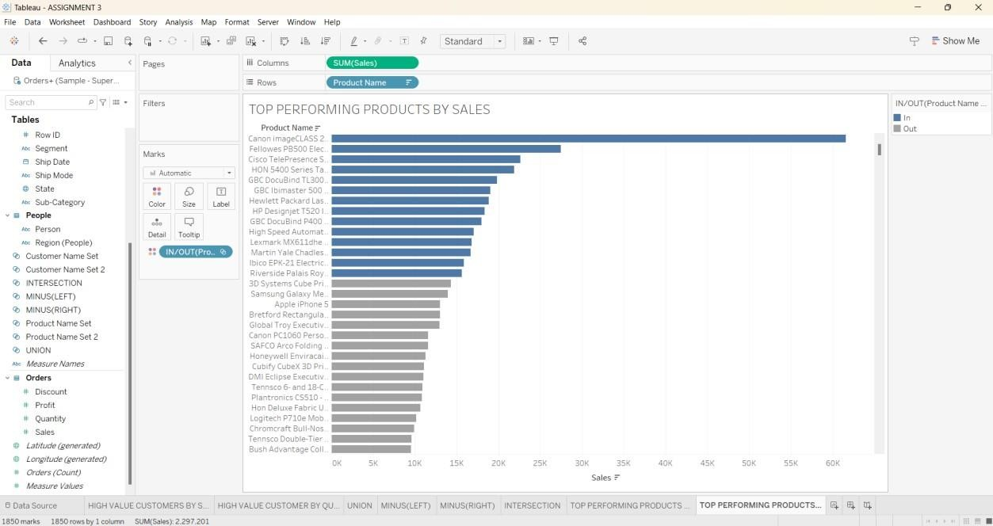

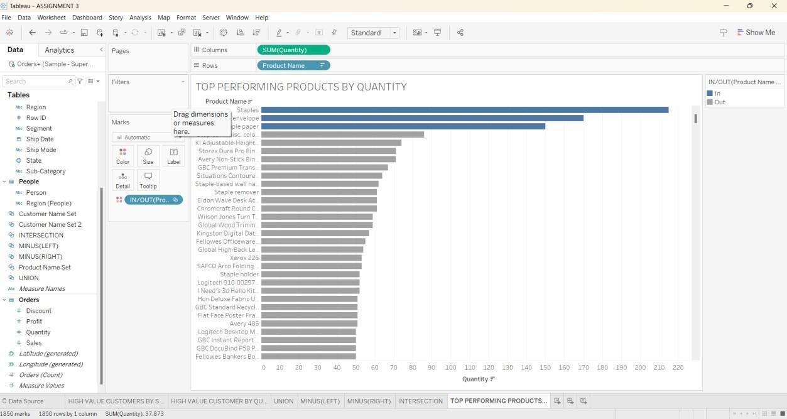

UNION OF TWO SETS

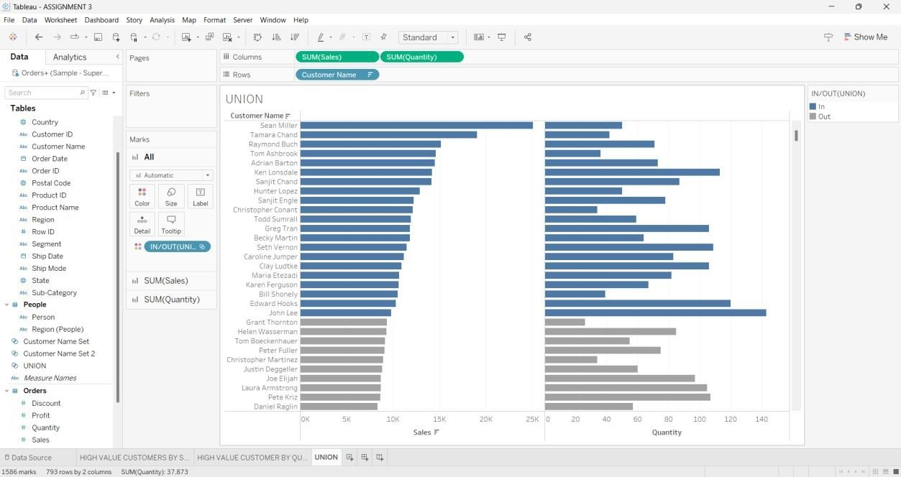

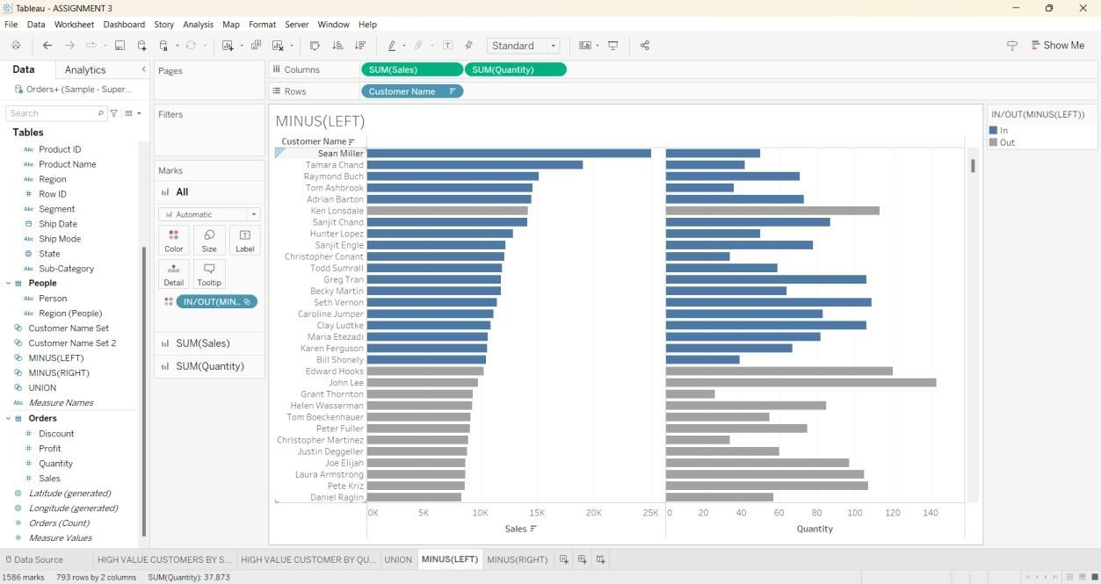

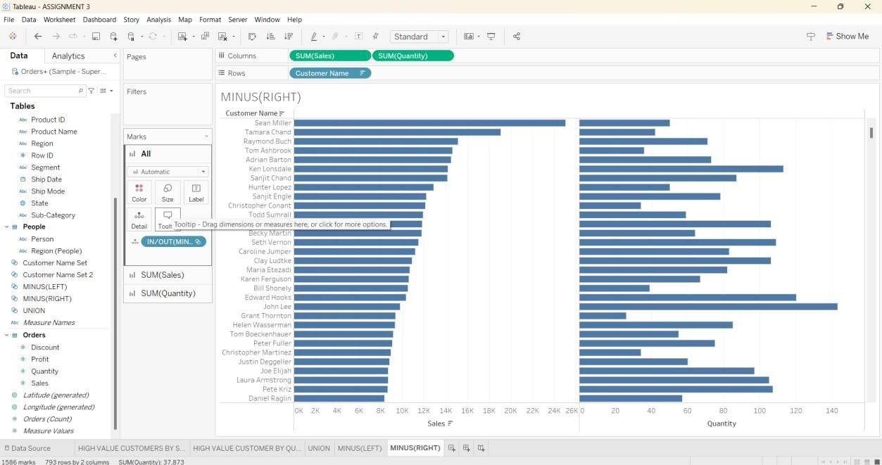MINUS (RIGHT JOIN) OF TWO SETS

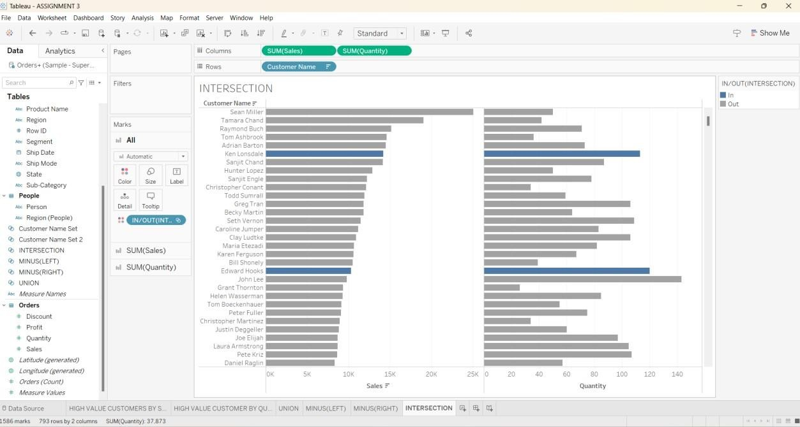

CALCULATED FIELD 1

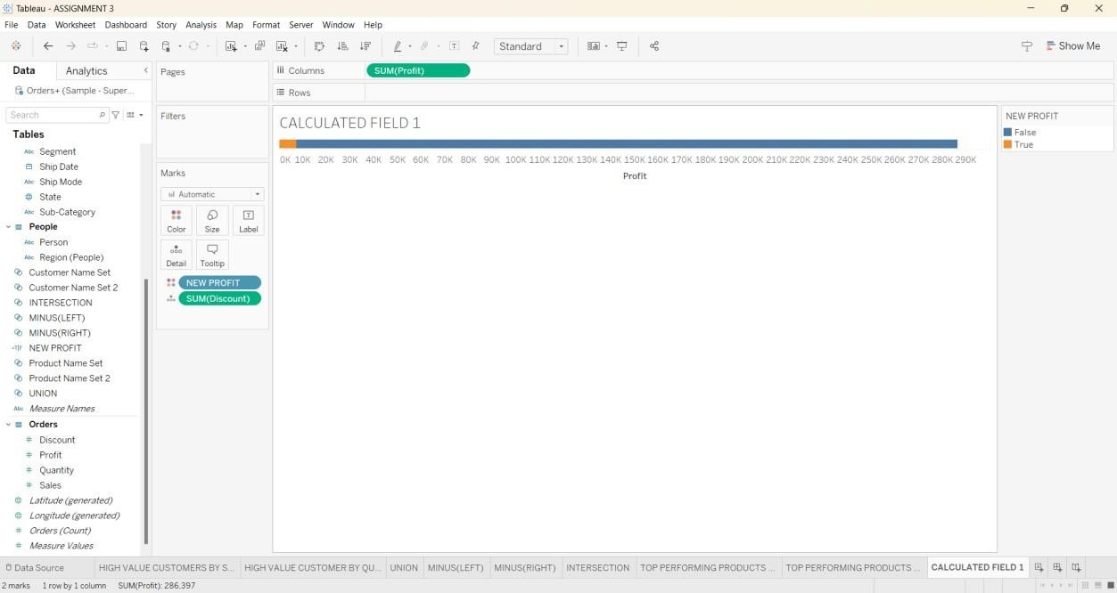

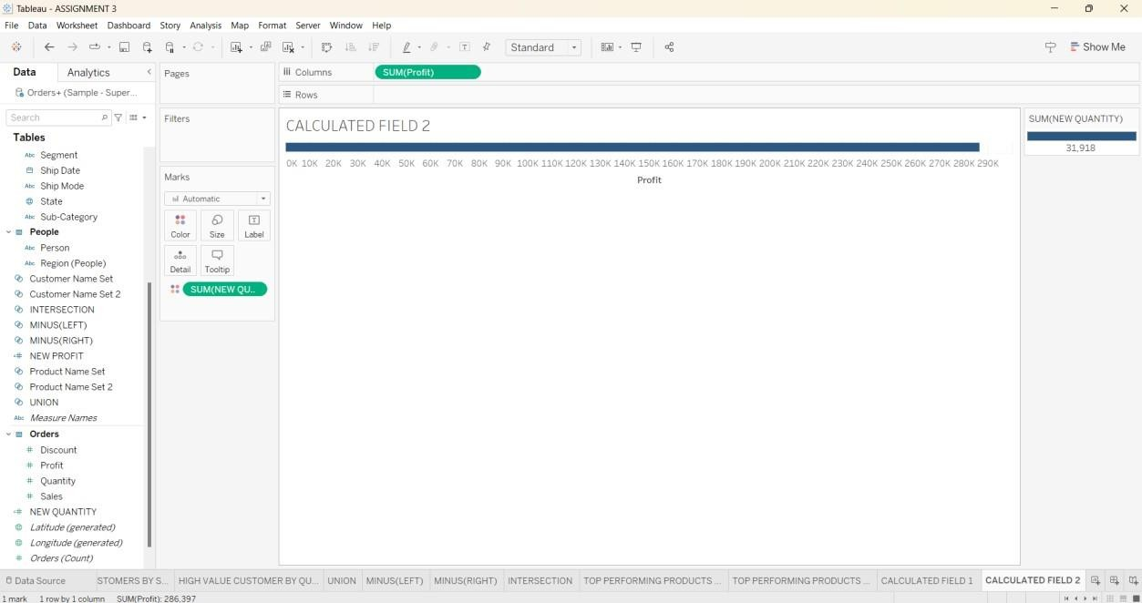

QUICK TABLE CALCULATIONS PERCENTILE

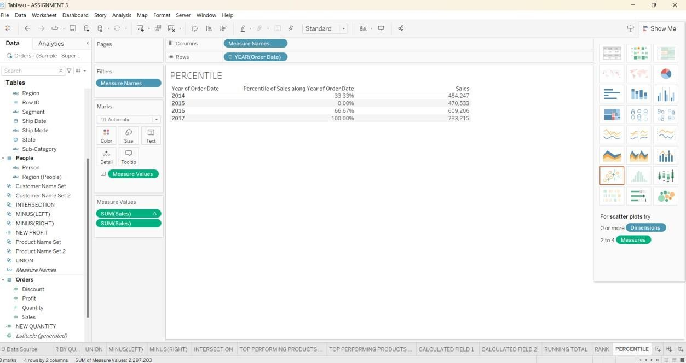

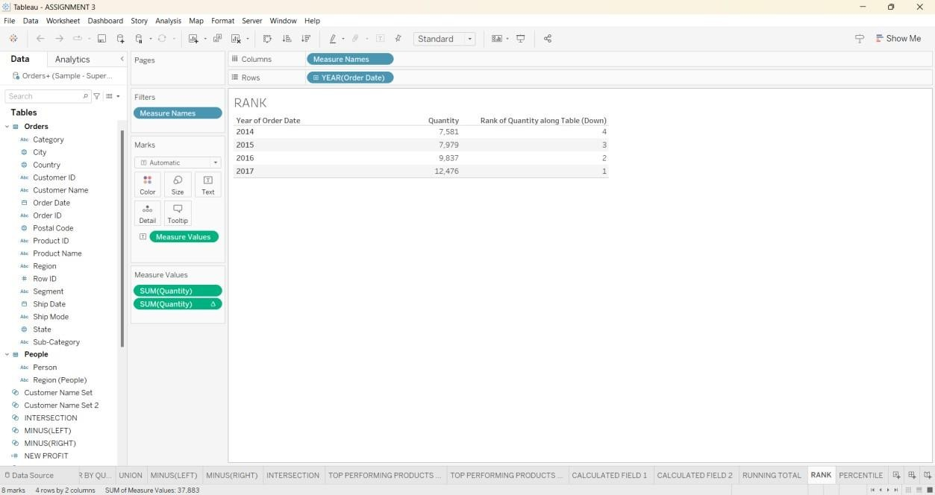

RUNNING TOTAL

